Lesson 10.8 Momentum and impulse

Recommended teaching time for this lesson: 1.5 x 60 minute periods

Period 1

• 40 minutes of explicit teaching

• 20 minutes of suggested classroom activities

• 40 minutes homework

Period 2

• 20 minutes of explicit teaching

• 10 minutes of suggested classroom activities

• 30 minutes homework

Getting started

Key ideas

* Momentum is the product of mass and velocity.
* A change in momentum can involve a change in velocity alone or a change in velocity and direction.
* Impulse is the rate at which momentum changes.

Curriculum links

Science understanding

* Describe the concepts of momentum and impulse.
* Analyse the area under a force–time graph using geometric methods.
* Solve problems involving momentum, impulse, the conservation of momentum and collisions in one dimension using $p=mv \text{and} ∑mv_{before}=∑mv_{after}.$

Advice for teaching this lesson

Things to know before you start teaching

This lesson will introduce momentum and impulse to students. Both topics are in the syllabus however only one equation is provided in the formula booklet. Unfortunately, the syllabus does mention that students should be able to interpret graphs that would use this equation. If you are an alternative sequence syllabus teacher, you should make students very aware that the impulse equation provided should be memorised.

One activity involves the throwing of eggs at sheets. While a video has been provided, it is a very enjoyable activity to do this outside with students. Note that while most egg allergies are in response to consuming eggs, very sensitive individuals can respond to touching eggshell. Consult the medical information for your class to decide whether to use the video or physical activity.

Common misconceptions

* Students often misunderstand that force and time just trade off each other for a fixed change of momentum. This means their predictions on scenarios will be incorrect.

Differentiation strategies

Encourage students to start preparing an ‘extra equations’ list at this point. This will vary depending on the syllabus you are using. Students should endeavour to practice writing out the equations by memory once a week at this point to ensure they can quickly recall them at the start of the final exam.

Starter activity: Would you rather?

Approximate time: 5 minutes

**Activity placement:** Place directly after Lesson overview

**Activity summary:** A polling activity to get students to consider that mass and velocity can combine.

Notes for the teacher

You could poll with hands, or having students move about the class. Consider asking students why they made their choice.

Instructions for students

Step 1: For each of the scenarios below, consider which you would rather be hit by.

* 1. A grade 7 running at 5 m/s, or a grade 12 running at 5 m/s?
  2. A scooter going at 5 m/s, or a scooter going at 20 m/s?
  3. A car going at 10 m/s, or a cricket ball going at 30 m/s?

Step 2: Share your choices with your class however your teacher decides.

Answers

1. Students generally choose the grade 7 with the justification that the mass is less.
2. Students generally choose the scooter at 5 m/s as it has a lower velocity.
3. This response is generally mixed, as one is heavy but slow, but the other is small and light.

Classroom activity: Turning momentum

Approximate time: 5 minutes

**Activity placement:** Place directly above “What is impulse?”

**Activity summary:** A small question about a scenario with no speed change, but only a change in direction.

Notes for the teacher

Remind students to consider that velocity has both magnitude and direction and any change in velocity will cause a change in momentum.

It can help to point out that a change in direction means that the original velocity has gone 0 m/s in that direction, and now it is the same number in a different direction, but the fact that the number is the same does not hold any special significance.

It is worthwhile getting students to share their answers and justification and demonstrating an exemplar response.

Instructions for students

Consider the following scenario and then answer the question below.  
*A car is driving at 100 km/h and takes a long 90 degree curve on the highway. At no time does the car’s speed drop below 100km/h.*

1. Has the momentum of the car changed? Explain your answer.

Helpful hints

* Consider what equation calculates momentum.

Answers

1. Yes, the momentum has changed. Momentum is a product of mass and velocity, and velocity requires direction. While the magnitude of the velocity did not change, the direction did, meaning that the car now has a new velocity, and hence a new momentum. The size will be the same, but the direction will be different.

Classroom activity: Egg throw

Approximate time: 10 minutes

**Activity placement:** Place directly above “How do you use force–time graphs?”

**Activity summary:** An activity to demonstrate that both force and time are factors of changing momentum.

Notes for the teacher

It is heavily encouraged to have students do this outside with you, but a video is provided.

Emphasise to students that the eggs’ forward momentum is being reduced to 0 Nm, which must be true, but how we reduce that momentum can change safety implications.

This video: <https://www.youtube.com/watch?v=7RSUjxiZnME> provides a good quick summary explanation at the end. The video provided for students does not explain the why.

Consult the medical information for your class to assess if the video or activity is most suitable due to allergies.

Instructions for students

Either watch the following video or your teacher will have you perform this activity hands on.

Throwing eggs! An egg-cellent impulse demonstration: <https://www.youtube.com/watch?v=K0ra7479zBs>

1. What is the final forwards momentum of the egg being thrown into the sheet?
2. If the change in momentum is 100% of the initial momentum, why does the egg not break?

Helpful hints

* The Δ*p* is set and cannot be changed, but what about force and time?

Support activity

Notes for the teacher

This version scaffolds out question ‘b’ from the base activity.

Instructions for students

Either watch the following video or your teacher will have you perform this activity hands on.

Throwing eggs! An egg-cellent impulse demonstration: <https://www.youtube.com/watch?v=K0ra7479zBs>

1. What is the final forwards momentum of the egg being thrown into the sheet?
2. Since the egg did not break, what does this imply about the force on the egg compared to being thrown at a wall?
3. If the change in momentum is 100% of the initial momentum, why does the egg not break?

Challenge activity

Notes for the teacher

This version requires students to use the equation to justify their answer.

Instructions for students

Either watch the following video or your teacher will have you perform this activity hands on.

Throwing eggs! An egg-cellent impulse demonstration: <https://www.youtube.com/watch?v=K0ra7479zBs>

1. What is the final forwards momentum of the egg being thrown into the sheet?
2. If the change in momentum is 100% of the initial momentum, why does the egg not break? Justify your answer using $∆p=Ft$.

Answers

1. 0 kg m s–1
2. While the impulse (change of momentum) is total as the momentum goes to 0 kg m s–1, the force and time can be varied. As these two are inverse of each other, if more time is taken to slow the egg down, then the force will be less.

Support activity

1. 0 kg m s–1
2. The force is less when thrown into a sheet compared to hitting a wall.
3. While the impulse (change of momentum) is total as the momentum goes to 0 kg m s–1, the force and time can be varied. As these two are inverse of each other, if more time is taken to slow the egg down, then the force will be less.

Challenge activity

1. 0 kg m s–1a
2. While the impulse (change of momentum) is total as the momentum goes to 0 kg m s–1, the force and time can be varied because these two are inverse of each other, as seen in the equation $∆p=Ft$. Since the impulse is set, if time increases force must decrease, meaning the egg won’t break.

Classroom activity: Areas of curved graphs

Approximate time: 10 minutes

**Activity placement:** Place directly above “Real-world Physics: Using impulse to design better running shoes”

**Activity summary:** A graphing activity to examine how to process non-linear graphs.

Notes for the teacher

If students can use their graphics calculators comfortably to solve this style of question they should do so. Students only need to communicate that they used a graphical calculator to calculate it to receive marks.

Remind students that the equation for this graph is not provided in the formula booklet, but it can be derived from equations given in the formula booklet.

Instructions for students

The graph below shows a curved force–time graph. This is similar to what you would see when examining a push being applied to an object, like a spring launcher on a cart.  
A force–time graph   
   
Calculate the impulse from the graph using the following techniques.

1. Approximate the area as a triangle.
2. Approximate the area using rectangles.
3. Approximate the area using trapezoids.
4. Which method do you think is the most accurate?

Helpful hints

* Try to set up your shapes to have some area outside of the graph, and some inside the graph to balance off the sections you miss with your shape.
* It will never be perfect.

Answers

1. Student answers will vary depending on how they set up the triangle. One example given.

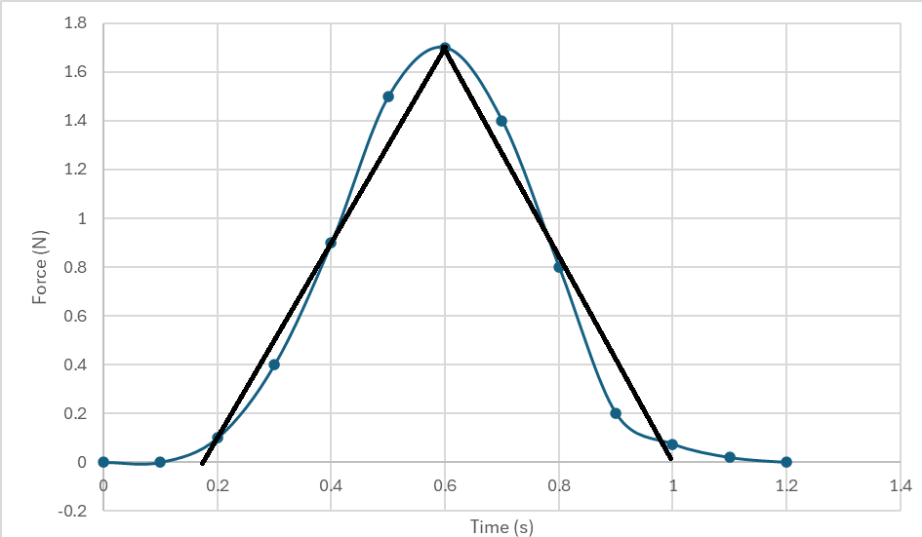

$$A=\frac{1}{2}bh \\ A=\frac{1}{2}×\left(1-0.18\right)×1.7 \\ A=0.697 Ns$$

1. Student answers will vary depending on how they set up the rectangles. One example given.

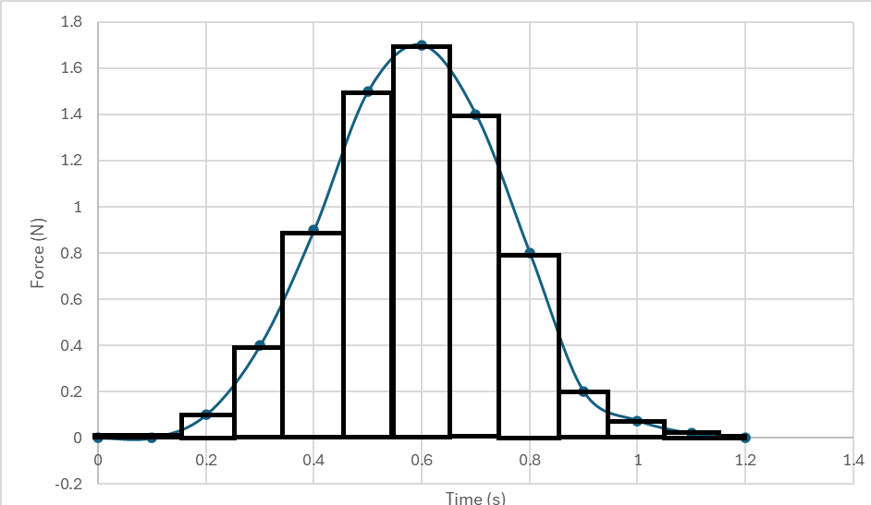

$$A= \sum{\left(y_{n}*0.1\right)} \\ A=0.1×0.1+0.4×0.1+…0.075×0.1+0.02×0.1 \\ A=0.709 Ns$$

1. Student answers will vary depending on how they set up the trapezoids. One example given.  
   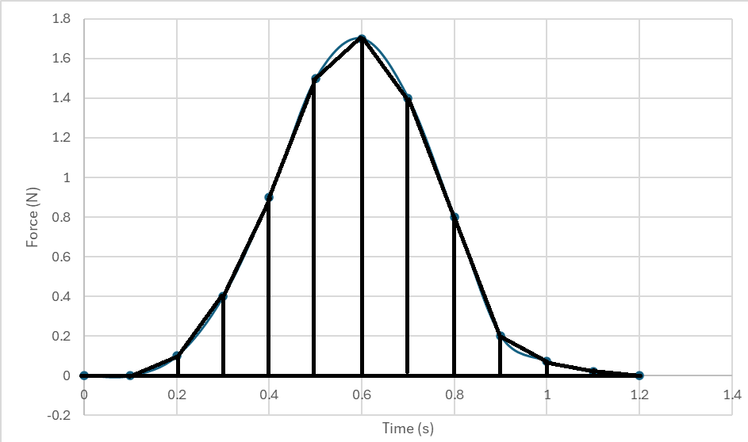 $$A=\sum{\frac{y_{n}+Y_{n-1}}{2}0.1} \\ A=\frac{0.1+0}{2}×0.1+\frac{0.4-0.1}{2}×0.1+…+\frac{0.02+0.075}{2}×0.1 \\ A=0.710 Ns$$
2. Trapezoids will be the most accurate.